# Task 1: Database Connection in the university.

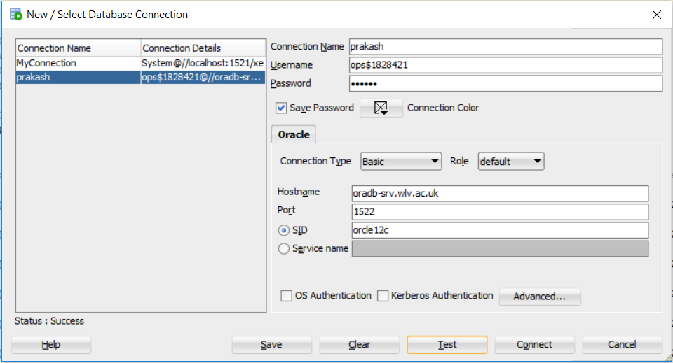

To make a connection, user name and password given by the university are to be provided.

# Task 2: Importing file in database.

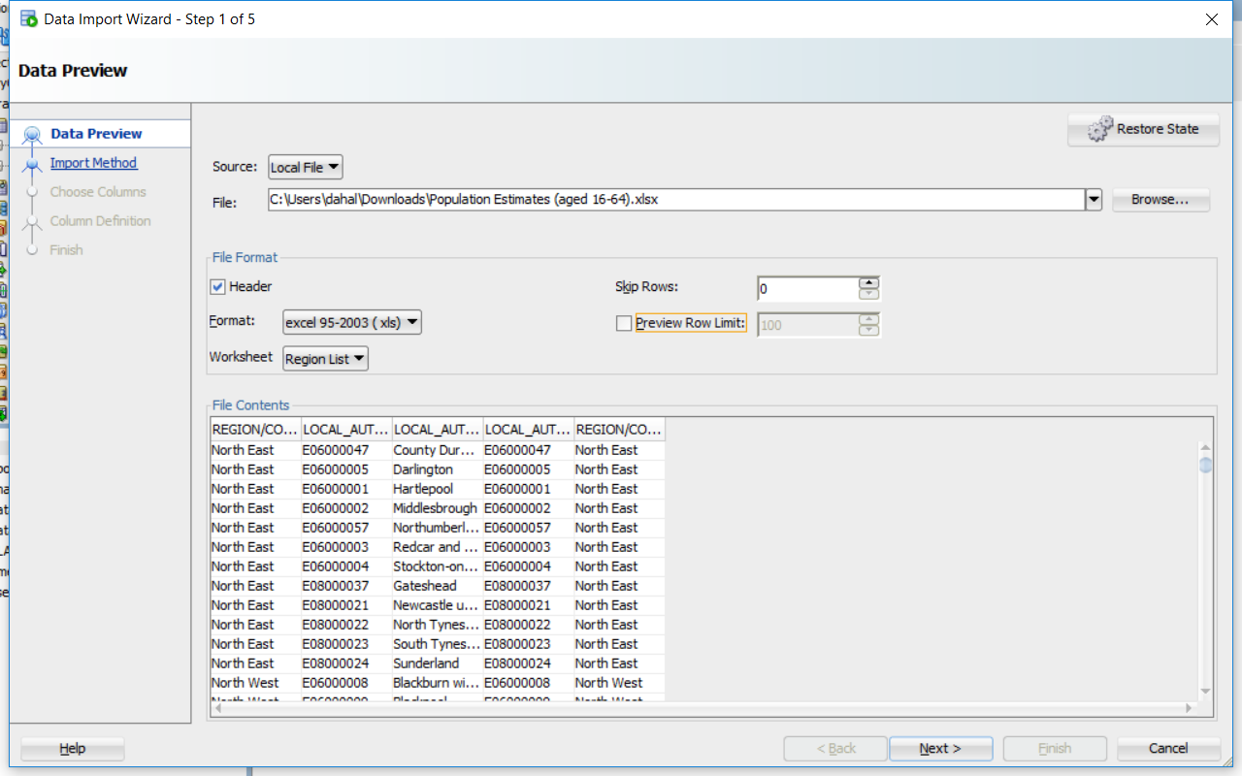

Importing Xls file locally.

# Task 3: SQL Queries.

1. SELECT COUNTRY_NAME, COUNT(*) AS COUNT FROM Region GROUP BY COUNTRY_NAME;

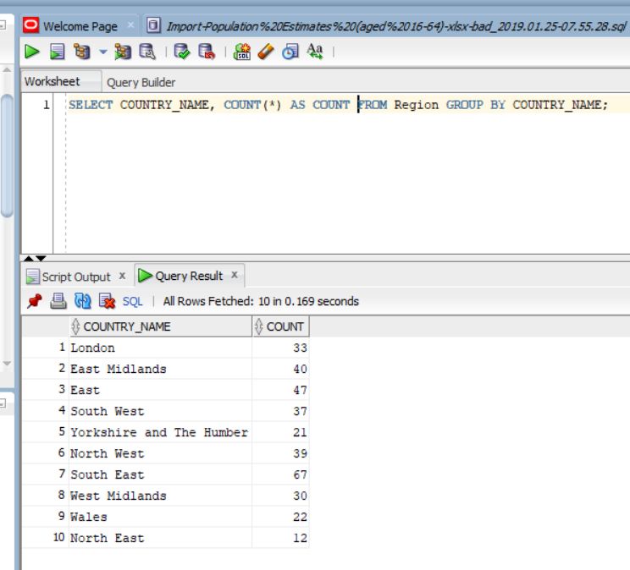

1. SELECT * FROM Region WHERE COUNTRY_NAME = 'West Midlands'ORDER BY LOCAL_AUTHORITY_NAME;

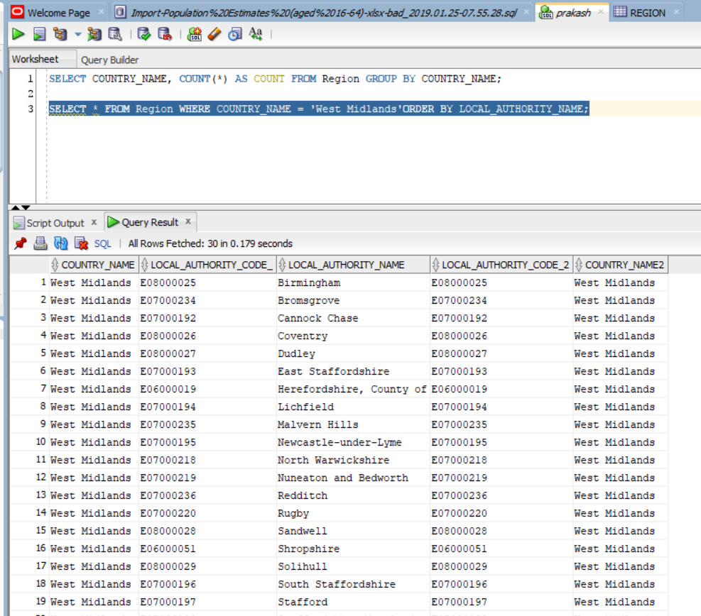

# Task 3: Changing Excel data.

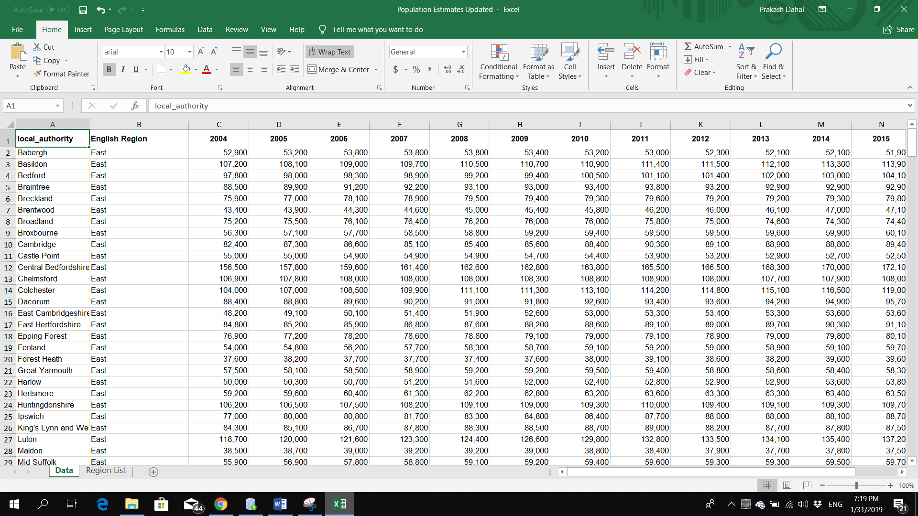

# Task 4: Importing Updated data.

Adding LA_ at the beginning of metadata of column years. Example (LA_2014)

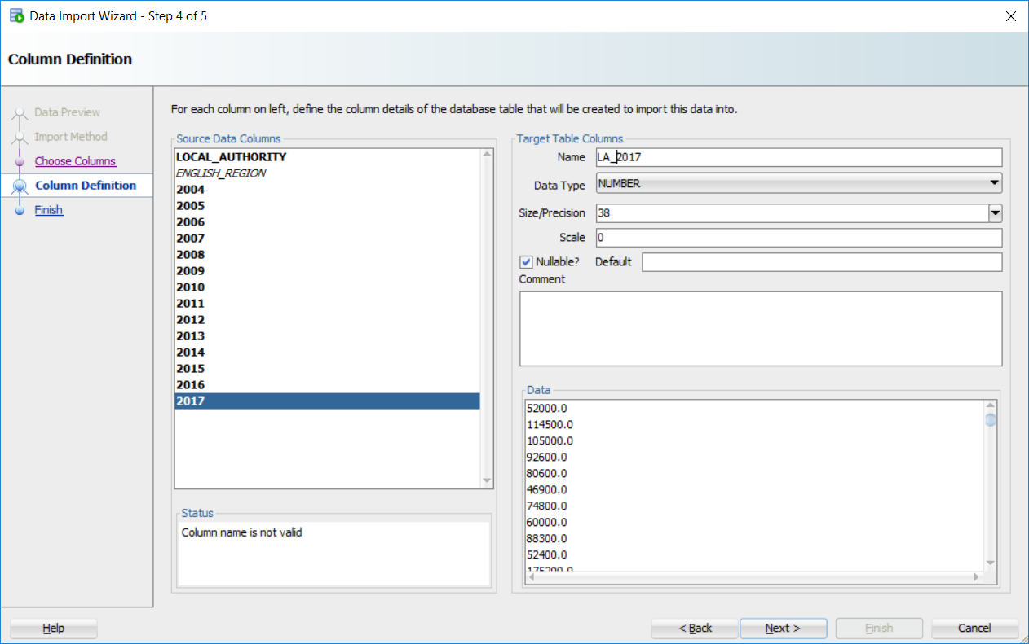

# Task 5: SQL on updated data.

1. SELECT COUNT(*) as POP_COUNT FROM population;

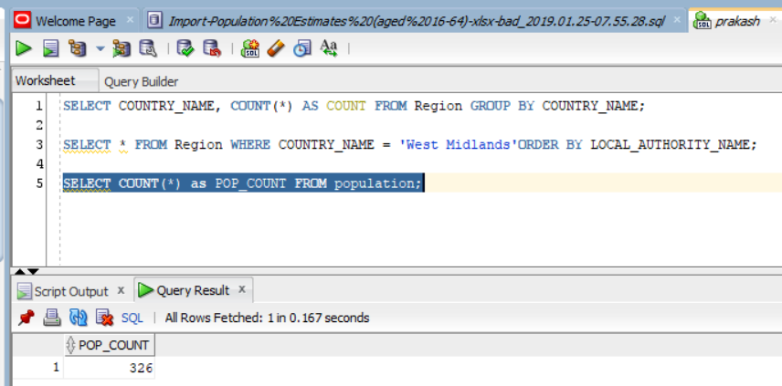

1. SELECT SUM(LA_2016) AS "2016", SUM(LA_2017) AS "2017"FROM POPULATION;

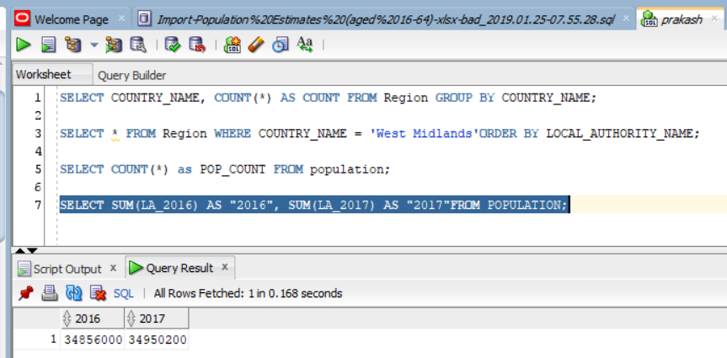

1. SELECT TO_CHAR(SUM(LA_2016),'999,999,999') AS "2016", TO_CHAR(SUM(LA_2017),'999,999,999') AS "2017" FROM POPULATION;

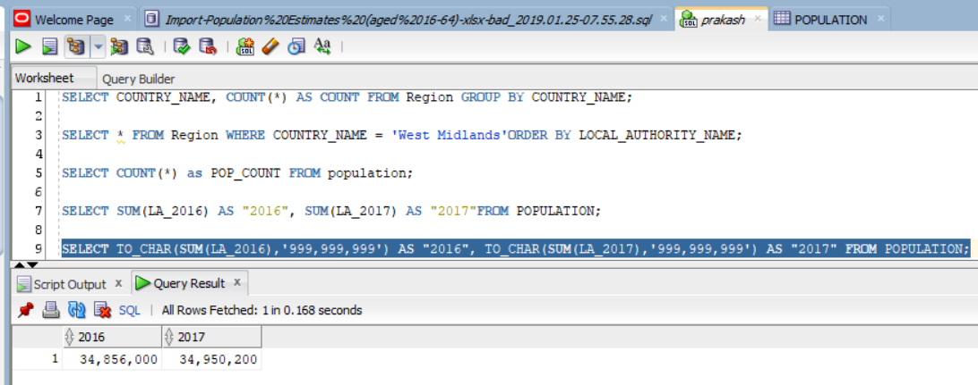

1. M SELECT COUNTRY_NAME, LOCAL_AUTHORITY_NAME, LOCAL_AUTHORITY_CODe_, LA_2015, LA_2016, LA_2017 FROM REGION R, POPULATION P WHERE R.LOCAL_AUTHORITY_NAME=P.LOCAL_AUTHORITY ORDER BY COUNTRY_NAME, LOCAL_AUTHORITY_NAME;

